Creating and submitting an invoice (Service Entry) in Ariba
Login to Ariba with your username and password:

1. Click on Create option on the Left Top Corner under Common Actions and Choose INVOICE from the Menu
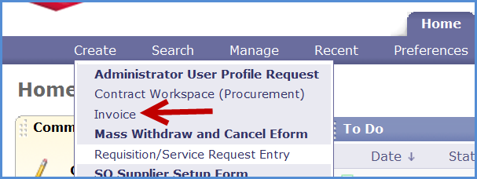
OR Click on the Invoice Tab and then click create from the ‘Common Actions’ menu
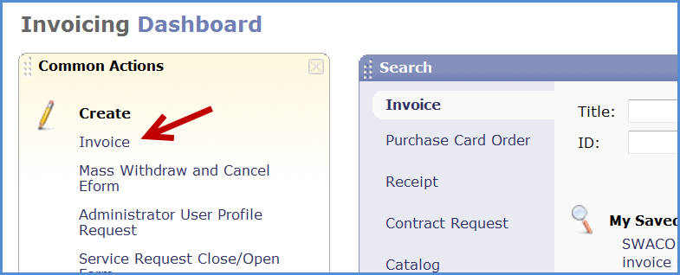

2. In the Title field – remove the default wording and replace as follows:
Enter the Title as follows;
-
- Your company name
- Month Service was provided
- Brief Description of Service
- Invoice Number

3. Enter your Service Order number in the search box starting with “0015******” then click search for more
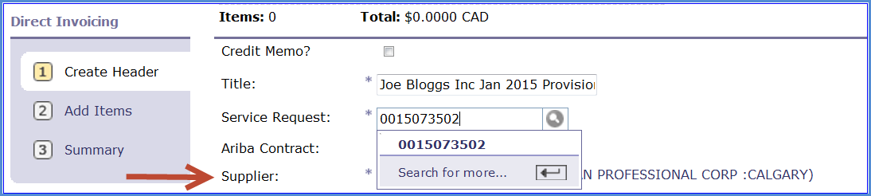
4. Note that Ariba will remember the number the next time you make the entry as long as you do not clear your internet history
Once the Service Request is selected it will populate certain fields in the header section – please do not change these fields
5. Enter the following information
Work Start Date & Work End Date by using the Calendar. Note you cannot enter work end dates in the future.
Supplier Work Ticket – if available
Invoice no – The number must match exactly as per the hard copy invoice you will attach
Suppliers tax amount
For GST enter only the applicable GST amount
For PST and GST the tax amount should include both
For HST enter only the applicable HST

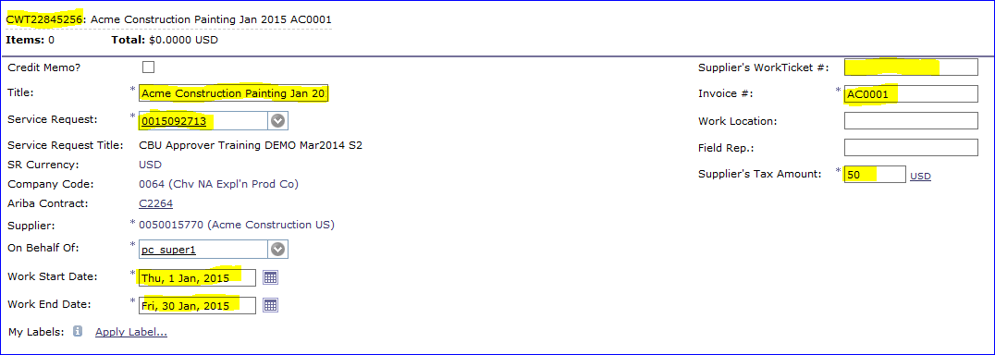
6. Click Next 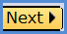
7. Click Add More Items
8. If the catalog is not visible immediately, Click Suppliers, then your Company name which will open up your catalog
Use the search field to search for your item if there are multiple items on your catalog
You can also sort your catalog by price nd set it to display 100 items per page
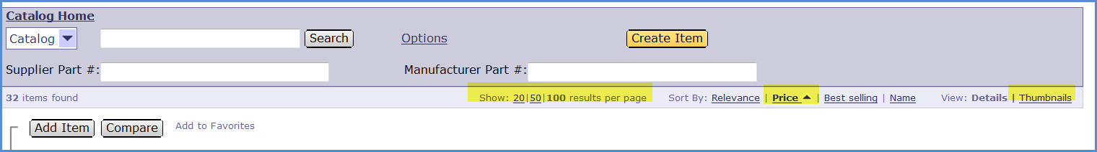
9. Once line item is found, you can enter a quantity and select “Add Item” which takes you to the next screen or you can add the quantity later.
You can also select multiple lines at the same time and add them to your cart in one step

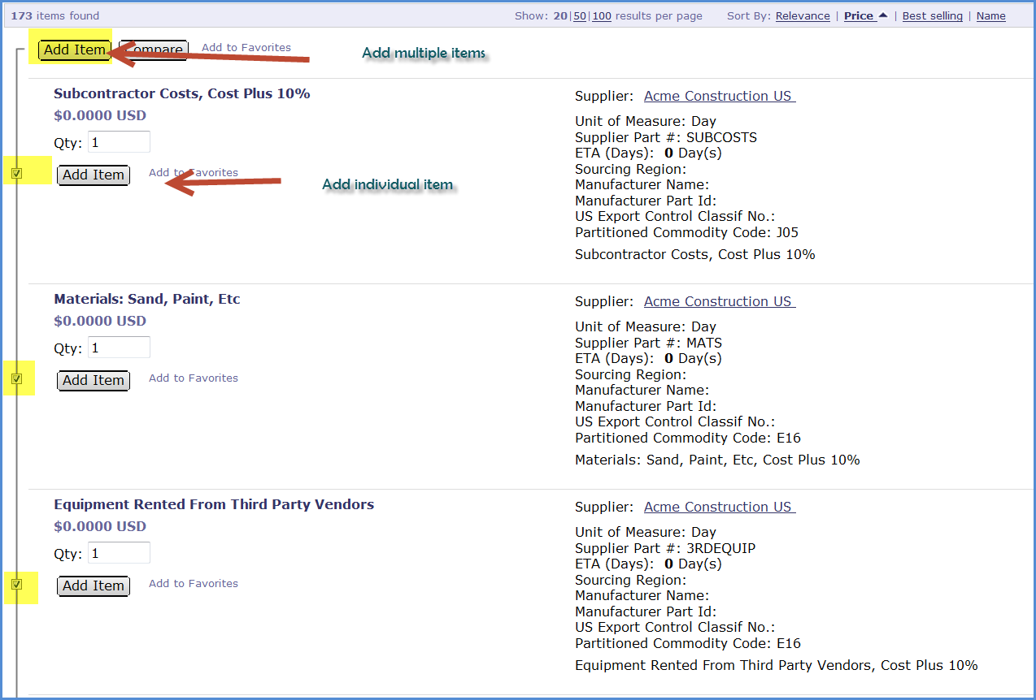

Note – if you cannot locate the item on your catalog, please contact CBUEPhelp@chevron.com who will advise whether the item should be added to the catalog before submission.

If they advise to create a non-catalog item please request assistance with this process
10. You can always add more items, click on “Add More Items” OR click “Summary” if you are done with items and go to the next screen.
Note: Add more items takes you back to your catalog to add more items
11. From the Summary screen
You may update the quantities here if required
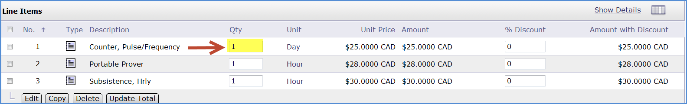
12. If you have chosen a zero priced item, highlight the relevant line, scroll down and click edit
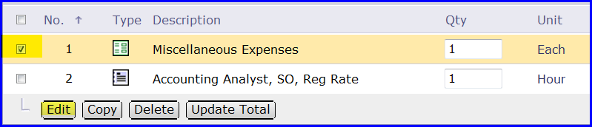

13. Scroll down and enter the amount in the base price and click OK either at the top or bottom of the screen
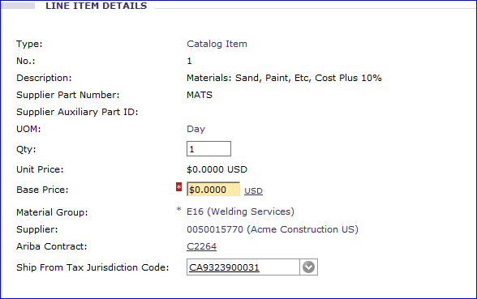
14. If any of the items being added are subject to zero tax or PST for BC province then you must amend the tax code on each relevant line
15. Select all lines or click relevant lines, scroll down and click edit
16. Change the tax code to R0 if item is not subject to tax and to R1 if the item is subject to PST

17. Once all zero items are modified, ensure the totals match:
Amount before discount, should be the sub total on your invoice before tax
Amount before Tax should be the sub total on your invoice before tax
Total should be the total amount after tax.
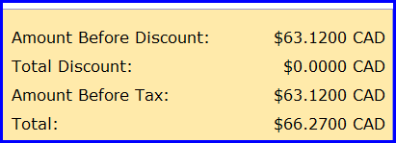
18. Scroll to the bottom of the screen, click the ‘Add Attachment’ button
19. Browse to where you have stored your soft copy invoice and relevant back up such as signed field tickets, signed timesheets and receipts.
20. Perform a final check ensuring invoice and all back up documents are attached and click submit 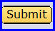
21. A message can be generated after clicking submit, this is because the system calculates the tax and works out to four decimal places, please ensure your tax value if correct to the nearest $0.01, correct if required. If all is Ok just keep clicking submit until you get the message
‘New Invoice – Submitted’
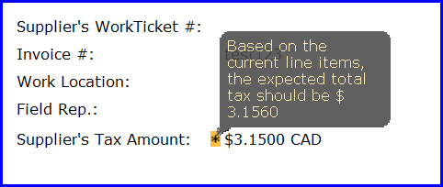

21. At each stage of the approval of the invoice, an email will be generated informing you of the approval and then an email when final approval has been given.
Note this does not mean the invoice has been paid but it has gone to onward processing for payment. Payment will be made as per agreed payment term, normally 30 days from submission of invoice.
Other things to note
- Invoice Status
  - Composing – Invoice is yet to be submitted to Chevron. You need to submit
  - Submitted – invoice has been submitted to Chevron and going through the approval process
  - Denied – Invoice that was submitted and reviewed is now denied, you are required to edit the invoice to make corrections then re-submit
  - Processed – Invoice is now fully approved in Ariba and payment will be made based on agreed payment terms

- Updating Cost Object information and Tax codes – please see document “Suppliers update costing information and Tax code”

- For more details on updating PST/GST Tax information – please see guide “Allocation of tax code for PST and Non Taxable items”

